

**International Foundation Diploma in Science, Technology, Engineering, Mathematics and Art**

**Programming Principles and Development**

**Batch Code: STMDB 2007A**

**Name: Sheldon Lee Smuts**

**Student ID: SIDI2007051421**

**Project Assignment 1**

**(Individual Assignment)**

**Due Date: 26-03-2021**



**Assignment 1**

Course Title: **International Foundation Diploma in Science, Technology, Engineering, Mathematics and Art**

Module Title: **Programming Principles and Development**

Batch No: **STMDB 2007A**

=======================================================================

Name: **Sheldon Lee Smuts**

##### Deadline: 26-March-2021

##### Submission

##### Date: 04 March 2021

**Project Mark (100 Marks)**

|  |  |  |  |
| --- | --- | --- | --- |
| S/No: | Description | Mark  Allocated | Mark  Awarded |
| 1 | Question 1 | 20 |  |
| 2 | Question 2 | 20 |  |
| 3 | Question 3 | 20 |  |
| 4 | Question 4 | 20 |  |
| 5 | Question 5 | 20 |  |
| Total: | | 100 |  |

Project (Individual Assignment)

**Question [20 marks each x 5 = 100 marks]**

|  |  |  |  |
| --- | --- | --- | --- |
| Write a program to print following : | | | |
| **i)** | ********** ********** ********** ********** | **ii)** | * ** *** **** ***** |
| **iii)** | *       **     ***   **** ***** | **iv)** | *       ***     *****   ******* ********* |
| **v)** | **1       222     33333   4444444 555555555** |  |  |

**Submission**

To submit your project, follow these steps:

1. Create a zip file that includes all the folders in Assignment 2.
2. After submitting your project make sure you download the submitted file and verify that what you have submitted is correct. Please do not e-mail your project.

Note:

**Softcopy is to be submitted through MDIS Blackboard LMS-Safe Assign Link.**

**Penalties:**

Penalties will be imposed for late submission as follow:

1. day late: 5% deduction
2. days late: 10% deduction
3. days late: 20% deduction
4. days late: 40% deduction
5. days late: 80% deduction

* 5 days: 0 mark

**Extenuating Circumstances –Unpredictable Events – Student Guidelines**

**Late Work will not be accepted. Deadlines should be adhered to. Only in exceptional circumstances, students seeking extensions or reschedules need to complete an official request for extension/extenuating circumstances. You need to fill in the correct form, which can be requested from the offices.**



**PLAGIARISM DECLARATION FORM**

This form must be completed, signed and attached to all assignments/projects/dissertations.

**Please complete the information below (using BLOCK LETTERS):**

**Student’s Name:**  Sheldon Lee Smuts **NRIC/FIN:** G3818662R

**Batch Code:**  STMDB 2007A **Module Name:** Programming Principles and Development

**Course Title: International Foundation Diploma in Science, Technology, Engineering, Mathematics and Art**

*The following definition of plagiarism is taken from the MLA Handbook for Writers of Research Papers, Theses, and Dissertations (MLA: New York, 1977, 99 4-5)*

*“Plagiarism may take the form of repeating another’s sentences as your own, adopting a particularly apt phrase as your own, paraphrasing someone else’s argument as your own, or even presenting someone else’s line of thinking in the development of a thesis as though it were your own. In short, to plagiarise is to give the impression that you have written or thought something that you have in fact borrowed from another. Although a writer may use other person’s words and thoughts they must be acknowledged as such (by the use of the appropriate reference, and by the insertion of quotation marks around any words directly quoted.”*

**PLAGIARISM DECLARATION**

1. I acknowledge and understand that plagiarism is wrong and that it constitutes academic theft.

2. I understand that my written work must be accurately referenced. I have followed the rules and conventions concerning referencing laid out in the course outline for this course.

3. I have not allowed, nor will I in the future allow, anyone, to copy my work with the intentions of passing

it off as his or her work. I also accept that submitting identical work to someone else (a syndicate assignment) constitutes a form of plagiarism. I accept that the same principle applies to authorized group work.

**PLAGIARISM WARNING**

1. Any student found to have committed or aided and abetted the offense of plagiarism may be subjected to the following penalties depending on the severity of his involvement in the offense.

i. The student shall receive no marks or a reduction of marks for the relevant academic assignment, project or dissertation;

ii. Subsequent offenses will attract more severe penalties, including possible termination of studies.

2. Students should seek clarification from their respective lecturers, tutors or supervisors if they are unsure whether they are plagiarising the work of another person.

**DECLARATION BY STUDENT**

I have read and understood the above definition of plagiarism. I am aware of and understand the Institute’s policy on plagiarism. I declare that all material in this assignment/project/dissertation is my own work and does not involve plagiarism.

**Student’s Signature:**  Sheldon Lee Smuts **Date:** 04 March 2021

Question 1

Answer

/*

Author Name: Sheldon Lee Smuts

Date: 04 - March - 2021

Description: Question 1 from C++ Assignment.

Need to print out the following.

**********

**********

**********

**********

*/

#include <iostream>

using namespace std;

int main()

{

int row,col, // Declaring the row and column.

rowNum, colNum; // Declaring the number of rows and columns.

cout << endl; // Adds a space from the top of the window.

cout << "This program will print out * in the number of rows and columns that you want." << endl; // Describes the programs function.

cout << "For the assignment you need to print 4 rows with 10 columns." << endl; // Describes the assignment Requirement.

// Get the input for the amount of rows.

cout << "\nPlease enter the amount of rows you will like to print: "; // Asks for the input for the number of rows.

cin >> rowNum; // input the value into the row number.

// Get the input for the amount of columns.

cout << "\nPlease enter the amount of columns you will like to print: "; // Asks for the input for the number of columns.

cin >> colNum; // inputs the value into the column number.

cout << endl << endl; // gives two spaces between the input and output.

// Takes the given Numbers and prints them out.

for (row = 1; row <= rowNum; row++) // for loop for the row

{

for (col = 1; col <= colNum; col++) // for loop for the Columns.

cout <<"*"; // Prints *

cout << endl; // Makes a new line

}

// Prints the number of rows and columns that where selected.

cout << endl; // Makes a new line

cout << "You have printed: " << rowNum << " Rows " << "With " << colNum << " Columns."; // Prints out the numbers for rows and columns you selected.

return 0;

}

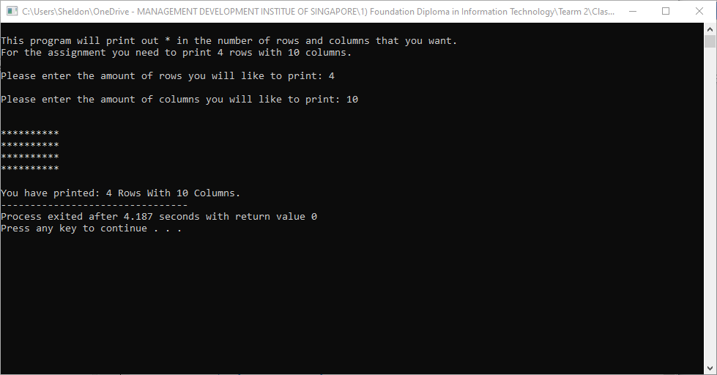

Question 2

Answer

/*

Author Name: Sheldon Lee Smuts

Date: 04 - March - 2021

Description: Question 2 from C++ Assignment.

Need to print out the following.

*

**

***

****

*****

*/

#include <iostream>

using namespace std;

int main()

{

int row,col, // Declaring the row and column.

rowNum; // Declaring the number of rows.

cout << endl; // Adds a space from the top of the window.

cout << "This program will print out * in the number of rows you select and add one * to each column." << endl; // Describes the programs function.

cout << "For the assignment you need to print 5 rows." << endl; // Describes the assignment Requirement.

// Get the input for the amount of rows.

cout << "\nPlease enter the amount of rows you will like to print: "; // Asks for the input for the number of rows.

cin >> rowNum; // input the value into the row number.

cout << endl << endl; // gives two spaces between the input and output.

// Takes the given Numbers and prints them out.

for (row = 1; row <= rowNum; row++) // for loop for the row.

{

for (col = 1; col <= row; col++) // for loop for the column.

cout << "*"; // Prints *

cout << endl; // Makes a new line.

}

// Prints the number of rows and columns that where selected.

cout << endl; // Makes a new line

cout << "You have printed: " << rowNum << " Rows "; // Prints out the numbers for rows you selected.

return 0;

}

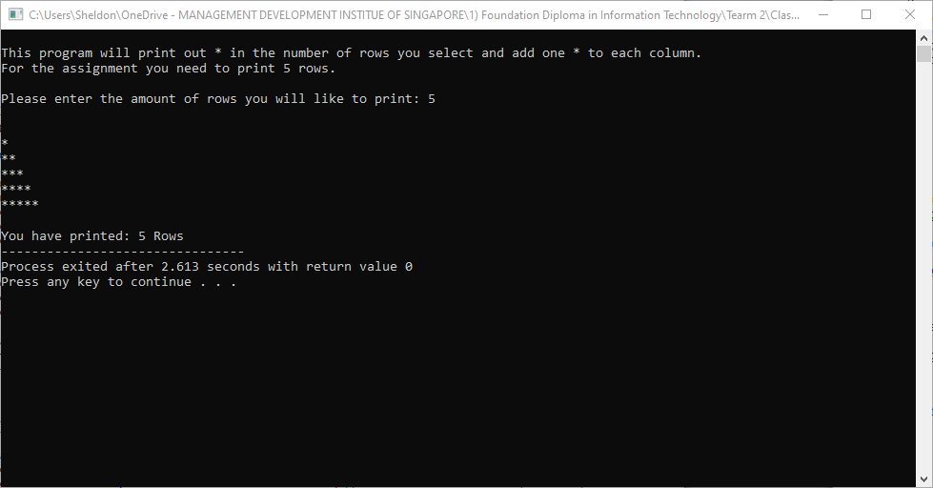

Question 3

Answer

/*

Author Name: Sheldon Lee Smuts

Date: 04 - March - 2021

Description: Question 3 from C++ Assignment.

Need to print out the following.

*

**

***

****

*****

*/

#include <iostream>

using namespace std;

int main()

{

int row, col, star, // Declaring the row and column and amount of *.

rowNum; // Declaring the number of rows and columns.

cout << endl; // Adds a space from the top of the window.

cout << "This program will print out * in the number of rows you select and add one * to each column with a space before." << endl; // Describes the programs function.

cout << "For the assignment you need to print 5 rows." << endl; // Describes the assignment Requirement.

// Get the input for the amount of rows.

cout << "\nPlease enter the amount of rows you will like to print: "; // Asks for the input for the number of rows.

cin >> rowNum; // input the value into the row number.

cout << endl << endl; // gives two spaces between the input and output.

// Takes the given Numbers and prints them out.

for (row = 1; row <= rowNum; row++) // for loop for the row.

{

for (col = rowNum; col > row; col--) // For loop to full the spaces.

cout << " "; // Prints the empty space.

for (star = 1; star <= row; star++) // for loop to print the *.

cout << "*"; // prints the *.

cout << endl; // makes a line space.

}

// Prints the number of rows and columns that where selected.

cout << endl; // Makes a new line

cout << "You have printed: " << rowNum << " Rows "; // Prints out the numbers for rows you selected.

return 0;

}

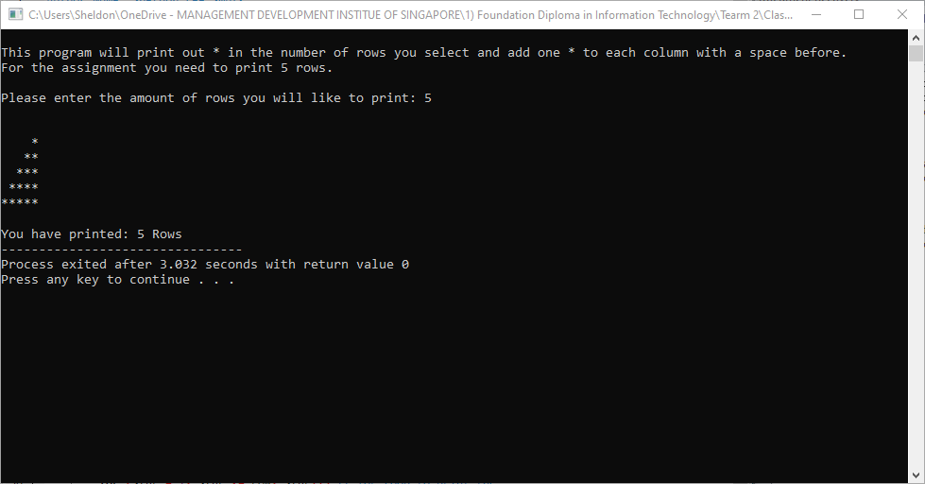

Question 4

Answer

/*

Author Name: Sheldon Lee Smuts

Date: 04 - March - 2021

Description: Question 4 from C++ Assignment.

Need to print out the following.

*

***

*****

*******

*********

*/

#include <iostream>

using namespace std;

int main()

{

int row, col, star, // Declaring the row and column and amount of *.

rowNum; // Declaring the number of rows and columns.

cout << endl; // Adds a space from the top of the window.

cout << "This program will print out * in the number of rows you select in a Pyramid shape." << endl; // Describes the programs function.

cout << "For the assignment you need to print 5 rows." << endl; // Describes the assignment Requirement.

// Get the input for the amount of rows.

cout << "\nPlease enter the amount of rows you will like to print: "; // Asks for the input for the number of rows.

cin >> rowNum; // input the value into the row number.

cout << endl << endl; // gives two spaces between the input and output.

// Takes the given Numbers and prints them out.

for (row = 1; row <= rowNum; row++) // for loop for the row.

{

for (col = rowNum; col > row; col--) // For loop to full the spaces.

cout << " "; // Prints the empty space.

for (star = 1; star < 2 * row; star++) // for loop to print the *.

cout << "*"; // prints the *.

cout << endl; // makes a line space.

}

// Prints the number of rows and columns that where selected.

cout << endl; // Makes a new line

cout << "You have printed: " << rowNum << " Rows "; // Prints out the numbers for rows you selected.

return 0;

}

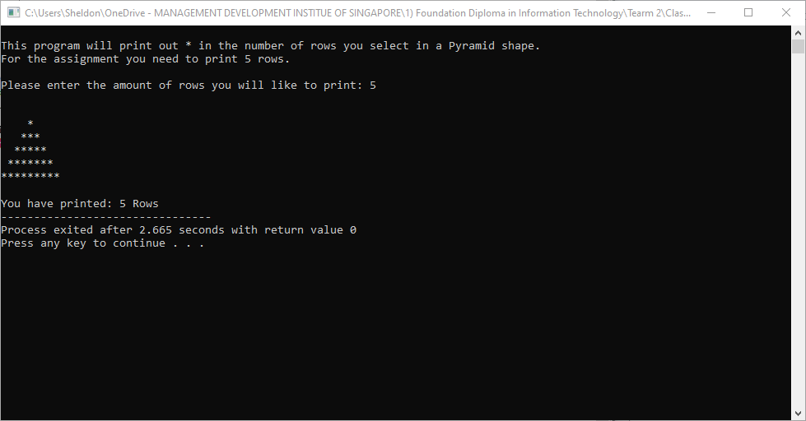

Question 5

Answer

/*

Author Name: Sheldon Lee Smuts

Date: 04 - March - 2021

Description: Question 5 from C++ Assignment.

Need to print out the following.

1

222

33333

4444444

555555555

*/

#include <iostream>

using namespace std;

int main()

{

int row, col, star, // Declaring the row and column and amount of *.

rowNum; // Declaring the number of rows and columns.

cout << endl; // Adds a space from the top of the window.

cout << "This program will print out the row number in the number of rows you select in a Pyramid shape." << endl; // Describes the programs function.

cout << "For the assignment you need to print 5 rows." << endl; // Describes the assignment Requirement.

// Get the input for the amount of rows.

cout << "\nPlease enter the amount of rows you will like to print between 1 and 9: "; // Asks for the input for the number of rows.

cin >> rowNum; // input the value into the row number.

cout << endl << endl; // gives two spaces between the input and output.

// Takes the given Numbers and prints them out.

for (row = 1; row <= rowNum; row++) // for loop for the row.

{

for (col = rowNum; col > row; col--) // For loop to full the spaces.

cout << " "; // Prints the empty space.

for (star = 1; star < 2 * row; star++) // for loop to print the row number and then multiply it by 2.

cout << row; // prints the row number the amount of time as the row number.

cout << endl; // makes a line space.

}

// Prints the number of rows and columns that where selected.

cout << endl; // Makes a new line

cout << "You have printed: " << rowNum << " Rows "; // Prints out the numbers for rows you selected.

return 0;

}

